

Afghanistan Civil Aviation Authority

ACAES Project

Document I

Software Project Management Plan- SPMP



Non-Technical Document | IEEE 1058 – 1998

Document | Version 1.0.0

April 2021 | Kabul, Afghanistan

ACAES Team | ACAA

Table of Contents

**Revision History** **4**

**Document approval** **5**

Definitions and Acronyms 6

Executive Summary **2**

1.1 About ACAA 2

1.2 Findings 3

1.3 Project Overview 5

1.3.1 Scope 9

1.3.2 Out of Scope 9

Project Stakeholders **10**

Stakeholders 10

Roles & Responsibilities 11

2.2.1 ACAA Technical teams 11

2.2.2 ACAES team 11

2.2.3 ACAA IT teams 12

2.2.4 TT teams (HR, Procurement) 12

2.2.5 USAID team 12

Management Process **13**

3.1 Assumptions, Dependencies, and Constraints 13

3.1.4.1 Risks during development 14

3.1.4.2 Risks after system go-live 15

Monitoring and Control Mechanisms **16**

Technical Process **19**

5.1 Methods, Tools, and Techniques 19

5.1.4 Clean architecture 23

5.1.4.1 Presentation Layer 25

5.1.4.2 Domain /Business Layer 25

5.1.4.3 Data Layer 25

5.2 Software Documentation 27

Minim server software requirement: 27

5.2 Hardware Documentation 27

Minimum Hardware requirements: 28

Work Packages, Schedules, and Budget **30**

Project Success Criteria **31**

Project Milestones 31

Approval Process 31

Data Conversion / Data Migration **33**

Test Strategy **34**

Unit Testing 34

Functional Testing 34

System Testing 34

Performance / Scalability Testing 34

Release and Deployment Plan **36**

Release and Pilots 36

Build and test of releases 37

Review and close a deployment 37

System version 38

System Transition / Rollout Plan **39**

Before Transition and rollout 39

After Transition 39

Training Plans **41**

Maintenance & Support Plans **42**

# **Revision History**

|  |  |  |  |
| --- | --- | --- | --- |
| Name | Date | Revision Description | Version |
| Fariba Tokhi | **May 20, 2021** |  | **Version 1.0.0** |
| Joseph Obonyo | **June 24 , 2021** |  | **Version 1.0.1** |
| Fariba Tokhi | **June 27, 2021** |  | **Version 2.0.0** |
|  |  |  |  |
|  |  |  |  |

# **Document approval**

This document was accepted and approved by the following:

|  |  |  |  |
| --- | --- | --- | --- |
| Signature | Printed Name | Title | Date |
|  |  |  |  |
|  |  |  |  |
|  |  |  |  |
|  |  |  |  |
|  |  |  |  |
|  |  |  |  |
|  |  |  |  |
|  |  |  |  |
|  |  |  |  |
|  |  |  |  |
|  |  |  |  |

# **Acronyms and Abbreviations**

The following table describes the abbreviation and acronyms used throughout this Software Project Management Plan SPMP

|  |  |
| --- | --- |
| Abbreviation | Meaning |
| ACAA | Afghanistan Civil Aviation Authority |
| ACAES | Afghanistan Civil Aviation Enterprise Solution |
| ADF | Airport Development Fee |
| AODB | Airport Operational Database |
| AOC | Air Operator Certificate |
| USAID | U.S. Agency for International Development |
| ACAES | Afghanistan Civil Aviation Enterprise Solution |
| RMS | Revenue Management System |
| ATM | Air Traffic Management |
| ATC | Air Traffic Control |
| ATS | Air Traffic Service |
| SRS | Software Requirements Specification |
| DSS | Data Storage System |
| HTTP | Hypertext Transfer Protocol |
| HTTPS | Hypertext Transfer Protocol Secure |
| FTP | File Transfer Protocol |
| SSL | Secure Sockets Layer |
| IATA | International Air Transport Authority |
| API | Application Programming Interface |
| BI | Business Intelligence |
| CAL | Civil Aviation Law |
| DB | Database |
| ERD | Entity Relationship Diagram |
| GUI | Graphical User Interface |
| H.E | His Excellency |
| ICT | Information Communication Technology |
| IEEE | Institute of Electrical and Electronics Engineering |
| IT | Information Technology |
| IVAO | International Civil Aviation Organization |
| LAN | Local Area Network |
| MET | Meteorology |
| PAX | Passenger Service Charges |
| UML | Unified Modelling Language |
| Tt | Tetra Tech |
| SPA | Single Page Application |
| ES | Enterprise Solution |
| IMSS | International Management System Standards |
| SPMP | Software Project Management Plan |

# Executive Summary

## 1.1 About ACAA

The Afghanistan Civil Aviation Authority (ACAA) was recently established based on the newly approved Civil Aviation Law (CAL) as an independent authority to manage the Civil Aviation Activities in the country. The Civil Aviation Law was endorsed by Parliament in October 2012 and approved by H.E. President Hamid Karzai in December 2012, and following the presidential confirmation, it was published in the official gazette of the Ministry of Justice in January 2013.

The duties and responsibilities of the Afghanistan Civil Aviation Authority are:

1. Development and implementation of policies related to the civil aviation
2. Regulating and monitoring activities of the air transport agencies and service providers in accordance with the international aviation conventions to which Afghanistan has acceded.
3. Regulating and monitoring activities of the air transport agencies and service providers in accordance with Afghanistan civil aviation law (CAL).
4. Issuing the Air Operator Certificate (AOC) to the air transport operators in accordance with the provision of this law.
5. Amending, renewing, suspending, and canceling the AOC in accordance with provisions contained in this law.
6. Issuing the Operation specifications and Airworthiness certificates
7. Signing Contracts and Memorandum of Understandings related to Civil Aviation with national and international organizations.
8. Maintain relations and representation of the country with the International Civil Aviation Organization (ICAO) and all other international civil aviation agencies.
9. Conducting necessary measurements for the registration of Civil Aircraft.
10. Prepare a plan for regulating the affairs related to spending of the development budget of the civil aviation services.
11. Protecting the interest of the beneficiaries of the civil aviation services.
12. Identifying the AOC holders who violate the terms contained in this law and their operation specification.
13. Obliging the AOC holders to recompense the damages inflicted due to violation of terms contained in the operation specification.
14. Leading and overseeing the Civil Aviation Training Institutes
15. Reporting to the relevant competent authorities and Ministry of Transport.  
    Performing other duties set forth in this law.
16. The Afghanistan Civil Aviation Authority is also responsible for all airports of Afghanistan, its operations and development.

## 1.2 Findings

The Afghanistan government has introduced several commercial revenue streams through newly created air corridors that paved the way for heavy business transactions enabling Afghanistan to attract public and private investments. However, the ACAA is strained by the increased number of air transport. Therefore, to facilitate, achieve, and exceed the requirements and standards set by International Civil Aviation Organization (ICAO) and International Management System Standards, the ACAA is bringing tremendous reforms that target the improvement of aviation services along with ensuring the financial sustainability of the system. Therefore, The ACAA is focusing on transferring civil Aviation services to a digitalized, transparent, and self-reliant sector in Afghanistan.

Civil Aviation sectors across the globe are using twenty-first century advanced technologies for their landside operations, airside operation, billing and revenue collection enabling them to better coordinate, organize, and manage various data sources, yet ACAA lacks basic operational information systems. Moreover, the internal data sources of the ACAA are too dispersed and do not comply with the international standards, which disabled ACCA to access the most recent and accurate data of the sector that can be used for creating future planning, policies, and regulation as well as providing information to the general public. Furthermore, the business processes are largely manual and the organizational revenue, resources, assets, and passenger information are scattered over many files and tables leaving ACAA crippled to manage its processes and information.

Furthermore, the ACAA struggles to collect and manage its revenues streams without possessing appropriate revenue systems, which lead ACAA to use uncoordinated channels for their revenues collection, which are:

Firstly, the ACAA overflights revenues are collected by a third party organization, IATA. IATA is expensively charging 1.25% admin fees on overflights revenue annually, which is a huge economic burden on the Afghanistan government.

Secondly, the ACAA charges airlines per Passenger Service Charges (PSX) from each passenger ticket that is travelling locally and internationally, however the charges are being collected by airlines, which sometimes causes irregularities in payments for the ACAA.

Finally, the remaining revenue streams i.e. Airport Development fee, Landing fee Charges, Parking fee charges, Lighting charges fee, Property rent Charges and 8-Electricity Charges, Pilot and Crew license fee, Penalty charges code are collected by airports. However, these revenues are collected in manual fashions disabling ACAA to receive transparent collected revenues.

Therefore, ACAA must have a business and revenue management system to help manage nearly all aspects of the airport's aeronautical, allowing it to pinpoint the most effective means to manage, track, and generate revenue.

Additionally, civil aviation across the globe are using lucrative safety management systems that facilitate making well-informed decisions, improves safety by reducing risk of accident, provides better resource allocation that will result in increased efficiencies and reduced costs, strengthens corporate culture, and demonstrates corporate due-diligence. However, ACAA is still using paper-based manuals for its safety management. Therefore, ACAA is in need to implement Safety Management Systems (SMS) at airports and airlines to improve aviation safety by helping airports and airlines to detect and correct safety problems before latent elements result in aircraft accidents or incidents.

Moreover, the ACAA lacks the implementation of the operational safety and compliance management that enforce and is responsible for the development of standards, recommended practices, procedures and guidance material related to the operation, certification and airworthiness of aircraft including instrument procedures design, the licensing and training of personnel and the safe transport of dangerous goods by air. That is, the ACAA must implement management systems to provide automatic alerts, email, and ad-hoc reporting as well as provide secure data transfer and field level security including to connect multiple airport divisions: Airside, Landside, Maintenance, Security, and Wildlife.

In conclusion, the civil aviation sector of Afghanistan is the key component of the local, national and regional infrastructure. Currently, ACAA has a deficit in comprehensive systems to cover the needs of the aviation sector. Therefore, there is a strong need for automation of the revenue and business management as well as for safety management and operational compliance that will have tremendous effect on overall growth of the ACAA’s landside operations, airside operations, and development of necessary information technology infrastructure for airlines.

## 1.3 Project Overview

ACAA technical team conducted a preliminary study of a number of airports and directorates on the needs and requirements for a solution to automate and improve business processes of ACAA and facilitate revenue collection, data processing, safety compliance, operations, and information sharing among directorates and entities. Throughout the requirements gathering, the aim was to conceptualize an enterprise solution that could address the general requirements of the aviation sector and all airports of Afghanistan. Further, in the long run, the system will provide a comprehensive e-System for all airports and a single point of control within ACAA. Therefore, we introduce the Civil Aviation Enterprise System, which will be an integrated application that works as one enterprise solution to provide comprehensive business process management with a high level reporting mechanism for different management layers.

Furthermore, the aforementioned enterprise solution will be rolled out in overall ACAA to facilitate airport operations i.e. landside operations, airside operation, resource management that is shared among ACAA departments providing automation and improvements of the internal processes as well as the provision of real-time data that will enable the ACAA with the required support to prepare effective and efficient plans and taking well-rounded decisions.

Generally, ACAES is generalized in four core components i.e. Revenue Management System, Safety Management System, Business Management System, Operational Compliance Management System, which is respectively classified in the following modules i.e. airport operational database(AODB), the landscape operations that includes passenger facilitation service, baggage handling, terminal management, staff management, resource and asset management, reporting, air traffic management and ground-handling system. Further, contract management, airport Information systems that includes flight Information display system, airport announcement system, and terminal management system.

Additionally, in order to have a collective outcome of the systems, particularly for the ACAA executives, one extended component is identified for the ACAES i.e. Business Intelligence (BI). The BI will support ACAES in better data analysis and reporting.

Presently, there are several systems in the market, which cover some part of the ACAES. However, these systems are designed based on the general practices of businesses and companies and require substantial customization and development to fulfill the ACAA requirements.

Furthermore, the ACAA technical team will carry out the project management life cycle as well as architectural design, development, implementation with collaboration of the related stakeholders. To improve the sustainability of the ACAES after implementation, the ACAA technical team will design and conduct needed training for the airport IT department for capacity building which eventually enable them to take over the support and maintenance functions of ACAES.

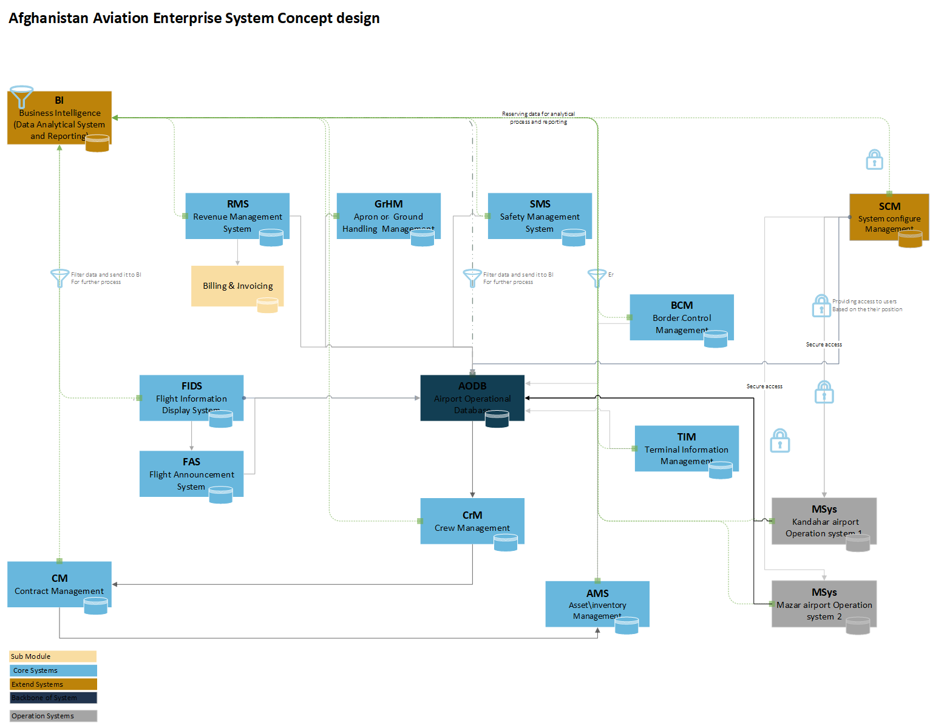

**Figure 1: Afghanistan Civil Aviation Enterprise System Concept Design - Part 1**

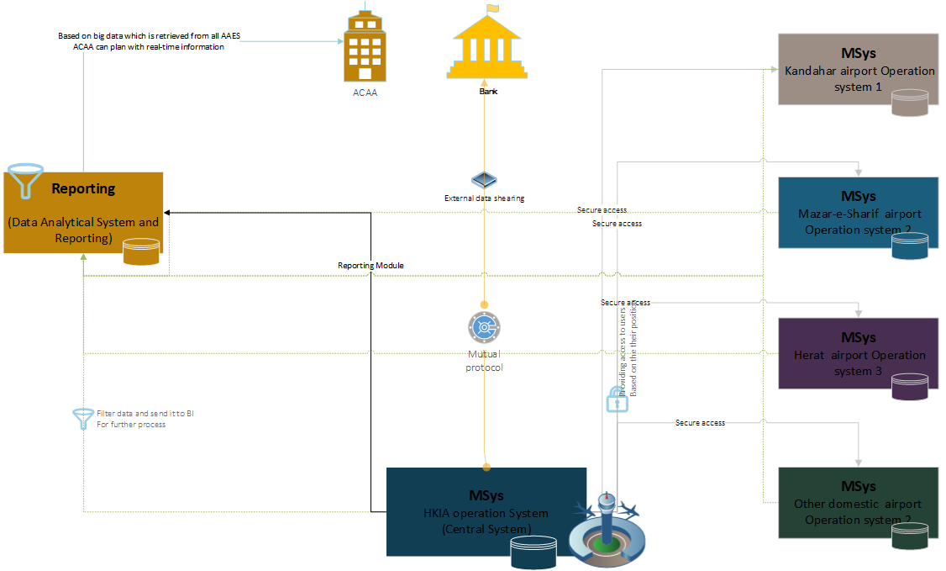

**Figure 2: Afghanistan Civil Aviation Enterprise System Concept Design - Part 2**

## 1.3.1 Scope

The following tasks are within the scope of this project:

* + 1. Project documentation based on the IEEE standards (SPMP, SRS, SDS, STD, SUM)
    2. Top down requirements
    3. Architecture, Design, Development and implementation including project management.
    4. Hardware configuration, if required
    5. Business Process re-engineering, where required
    6. Data migrations from existing databases to new database
    7. Technical training and end-user training
    8. System support and maintenance plan
    9. System localization
    10. Purchasing hardware and software license for system hosting
    11. Building Data Center at MET

## 1.3.2 Out of Scope

The following tasks are out of scope of the project.

* + 1. Restructuring of the official government forms
    2. Exporting data to mobile devices
    3. Connecting with provinces in the first phase
    4. Constructing new buildings, rooms, etc.
    5. Purchasing hardware and software for end user

# Project Stakeholders

## Stakeholders

Stakeholders are individuals or (government) entities that directly or indirectly affect project deliverables. ACAA is the main stakeholder and responsible who will receive the product as the result of the project. ACAA responsible for design, development and implementation of the new system and for technical support.

Tetra Tech is a stakeholder responsible for recruitment of technical staff, procurement of project hardware, software and working space items and liaison between ACAA and USAID.

USAID is the stakeholder that is funding the entire project implementation.

In accordance with the project design, each of the above mentioned stakeholders will be involved in specific activities within the project life cycle.

The ACAA IT team will be involved from the start of the project, during requirement gathering, design, development and implementation. Involving the ACAA IT team from the beginning will improve their understanding for each phase of the project and transferring the technical knowledge will improve the project sustainability. 10 days of highly technical training is planned to be conducted in ACAA IT department to build their capacity.

The ACAA IT team will be involved in technical development of the system. According to common practices, this type of involvement will positively affect the long-term maintenance and sustainability of the system

## Roles & Responsibilities

Following are the roles and responsibilities of the different stakeholders of the project:

As mentioned ACAA t is the main stakeholders for this project and different teams from ACAA are involved to successfully complete the project. Presently, ACAA technical team leading this project with the following roles and responsibilities:

### 2.2.1 ACAA Technical teams

* 1. Project management
  2. Requirement verification and analyzing
  3. Project concept design and technical documentation

### 2.2.2 ACAES team

This team is responsible for accomplishing the following tasks:

* 1. Collecting new and future requirements
  2. Initial analysis of the requirements collected
  3. Documenting the new requirements
  4. Requirement based testing of the system after development
  5. System deployment, after technical training and system development
  6. End user training
  7. System support and maintenance
  8. Architecture and design based on the requirements
  9. System prototyping
  10. System development and system implementation
  11. Assisting the ACAA IT team during deployment and maintenance
  12. Provide technical training

### 2.2.3 ACAA IT teams

* 1. Project maintenance
  2. Assisting in providing end-user training
  3. Post go-live operations

### 2.2.4 TT teams (HR, Procurement)

* 1. Staff recruitment
  2. Hardware and software license procurement
  3. Project liaison with USAID

### 2.2.5 USAID team

* 1. Financial support

# Management Process

## 3.1 Assumptions, Dependencies, and Constraints

The ACAES being a very sensitive system during every phase, it is crucial to have a very strict and stringent project management in place. Therefore, understanding the assumptions, dependencies, risks and constraints is paramount to avoid failure.

**3.1.1 Assumptions**

The following assumption which may affect project design, development and implementation, must be valid to ensure a successful project process:

* 1. End-users shall be responsive to the requirement team for business process information during requirement collection and analysis
  2. End-users shall have basic computer knowledge and good understanding of their current business processes
  3. ACAA director and other relevant top level staff should be available at all times to support project design, development and implementation.
  4. The ACAA IT and Technical team should readily provide technical information and data about current system

**3.1.2 Dependencies**

There are many dependencies within ACAES processes, which directly affect the project. These dependencies are to be considered prior to and after project implementation. The dependencies can be grouped into two categories: inter- agency dependencies, that is, dependencies between ACAES and other agencies likeAirline and The Afghanistan bank, Payment gateway etc, and technical dependencies. The technical dependencies are listed below:

* 1. Availability of technical resources
  2. Users should understand the system data flow for their specific role
  3. Local network should be up 24/7
  4. Stable and redundant power supply should permanently be available
  5. An on-call maintenance team should be available 24/7
  6. Backup servers should be available 24/7

**3.1.3 Constraints**

The constraints of a project can slow down or completely stop the project whenever a resource is not available when needed. During the design and development phase of the ACAES, it is vital that all resources e.g. technical staff, budget, hardware, sufficient time for procurement, should be allocated for the project based on the project timeframe.

**3.1.4 Risk Management**

It is crucial that potential risks are identified early in the project. During the project requirement gathering and project design, there should be good policies to identify potential risks within the project and address those potential risks with proactive solutions. There should be a good mechanism in place to mitigate project risks especially those with big impact.

The following risks have been identified during the development phase and risks after system go-live:

### 3.1.4.1 Risks during development

* + 1. Requirements change after system design (scope creep)
    2. Losing highly qualified technical staff during project development
    3. Complete damage, destruction or loss of the development systems
    4. Wrong infrastructure which is designed not in accordance with system requirements

In order to mitigate or address with right solution to the identified risks, the following solution should be considered if any of them occurred:

* + 1. Requirements change with big impact should be scheduled for the next version
    2. A backup of highly qualified technical team member should always be available who act as backup
    3. Daily backups shall minimize impact of damage to the development system. A good versioning system shall avoid confusion in case a restore is needed.
    4. Before go-live the infrastructure shall be tested with system requirements

### 3.1.4.2 Risks after system go-live

Risks after systems go-live are listed below:

* + 1. Damage or destruction to the server rooms
    2. Network stops responding
    3. Backups are not conducted on time and schedule
    4. Unexpected system errors

Backups are used to restore the system in the event that the main server room is damaged or destroyed. Standardized communication procedures and a responsive trouble shooting team shall reduce troubleshooting time to minimal. Similarly, well established network trouble recognition and trouble solving procedures and a well-equipped KNOK shall help minimize network downtime.

# Monitoring and Control Mechanisms

Presently, the monitoring and control mechanisms will be applied on the resources and project activities according to the predefined project guidelines (**software development and project management best practices**). Thus, every single resource activity will be reported to the senior software engineer and then to Senior MIS Specialist-ACAA (project manager) and software development Project Manager -Tt in accordance with their timeframe. The project managers are responsible to ensure that the project resource is delivering the specific activities in accordance with predefined guidelines and the project work plan. In-case of daily activities, the project manager is required to understand the situation and reallocate or double the resource to improve the delivery and quality.

To ensure predefined project guidelines are applied within the project costs, resources and time frame, the project work plan including schedule and guidelines shall be shared with all project stakeholders.

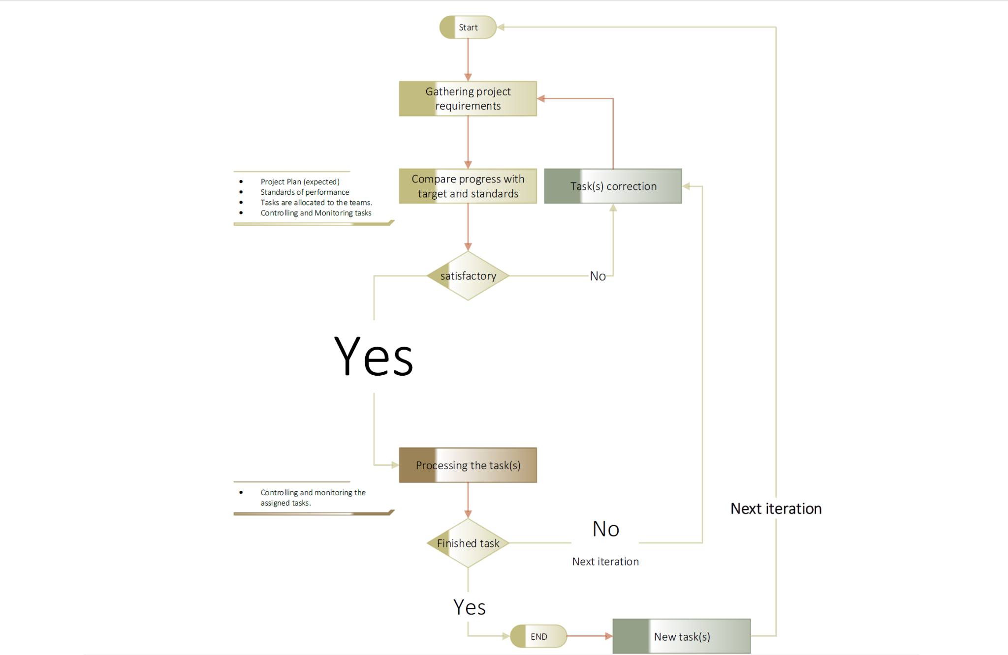

**Figure 3: Monitoring and Controlling mechanism flow**

# Technical Process

## 5.1 Methods, Tools, and Techniques

The ACAES will be developed by **Microsoft .Net core and Angular.**

**The** [**.NET Core**](https://docs.microsoft.com/en-us/dotnet/core/about) is an [open-source](https://github.com/dotnet/runtime/blob/master/LICENSE.TXT), general-purpose development platform maintained by Microsoft and the .NET community on [GitHub](https://github.com/dotnet/core). It's cross-platform (supporting Windows, macOS, and Linux) and can be used to develop web applications.

**Angular** is a TypeScript-based open-source web application framework led by the Angular Team at Google and by a community of individuals and corporations.

**5.1.1 Development Methodology**

After studying the overall system requirements and based on the best practices the system was developed using the agile application development methodology. The reason this methodology is used is twofold. First, requirements always change; second, due to the time limitations and required change-management the system will be developed in many different phases (see development phases).

**Agile Methodology**

Agile software development methodology is a group of [software development](http://en.wikipedia.org/wiki/Software_development_methodologies) [methods](http://en.wikipedia.org/wiki/Software_development_methodologies) in which requirements and solutions evolve through collaboration between self-organizing, [cross-functional teams.](http://en.wikipedia.org/wiki/Cross-functional_team) It promotes adaptive planning, evolutionary development, early delivery, continuous improvement and encourages rapid and flexible response to change. It is a conceptual framework that focuses on frequently delivering small increments of working software.

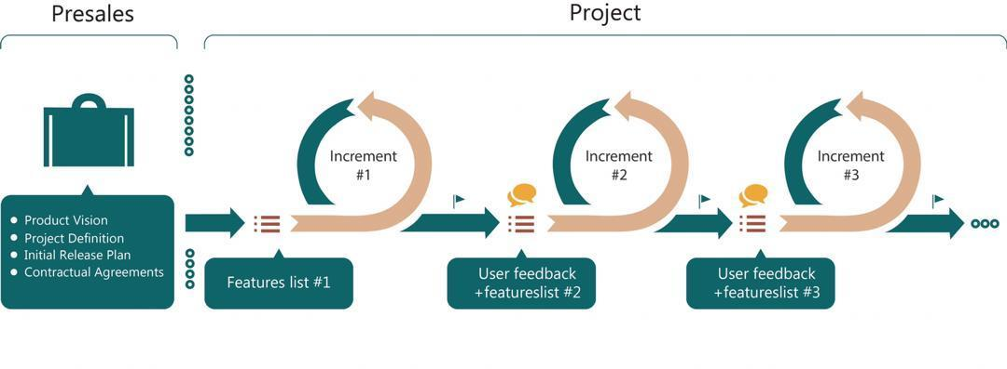

**Figure 4: Agile development cycle**

**5.1.2 Project Change Management**

Considering the Agile development methodology, the changes are managed and implemented to systems time-to-time according to the impact size. As and when needed, new changes will be gathered and analyzed by the ACAES technical team. If the change is not affecting the overall system structure then that change will be implemented within the system, otherwise the change will be scheduled for implementation in the next version.

**5.1.3 Development technology**

Selecting a technology for system development is required to understand the system requirement range and resource/technology availability in the market with reasonable price. Taking into account the following facts, the technical team proposed the following development technologies:

**Business logic layer**

* 1. Microsoft .NET core v5
  2. Command Query Responsibility segregation CQRS
  3. Mediator pattern

**Presentation a layer (Interface)**

* 1. Angular 11.2.12
  2. JSON
  3. JavaScript / JQuery
  4. CSS 3 – Cascading Style Sheet
  5. HTML 5

**Backend (data layer)**

* 1. Microsoft SQL Server 2014

**. Net Core**

The development of ACAES required a sustainable and secure development language to speed up the process of development without risking its data security. Therein, the team of experts in the project selected **.Net core** as the base for the development of ACAES with the intention to speed up the process of development and have an easy to learn standard for the ACAA IT department enabling them to further enhance and modify the system when necessary.

**Angular**

As aforementioned development of ACAES needs sustainable and secure development by considering all the aspects of securing data.Therefore, the development team selected the Angular framework for project front-side development. This will help us to deploy application front (presentation) at different servers to reduce security risk. The data will be exchanged in encrypted format between application layer and business logic layer. Meanwhile using anular there is no need to update the whole application while sending new requests to update, as angular it self is used for SPA applications .

### 5.1.4 Clean architecture

[**Clean architecture**](https://www.amazon.com/gp/product/0134494164/ref=as_li_qf_asin_il_tl?ie=UTF8&tag=gilvegliachit-20&creative=9325&linkCode=as2&creativeASIN=0134494164&linkId=33953467486873906bd7ffe63c538bde) **,** divides system to the Presentation, Domain and data management layer the arrangement of those lays, and the ways those layer communicate is behind use of the dependency inversion principle that, firstly, maintain and place boundaries between high-level components and low-level components, secondly, allow layer to be developed and deployed independently.



**Figure 5: Clean Architecture**

By segregating an application into layer, developer acquire the option of modifying or adding a specific layer, instead of reworking the entire application

The architecture facilitates the developer with development, deployment, operation and maintenance of the system to create flexible, reusable and maintainable applications.

Clean architecture provides the following benefits.

* 1. **Scalability**

Each tier can scale horizontally. For example, you can load- balance the Presentation tier among 3 servers to satisfy more Web requests without adding servers to the Application and Data tiers.

* 1. **Performance**

Because the Presentation tier can cache requests, network utilization is minimized, and the load is reduced on the Application and Data tiers. If needed, you can load-balance any tier.

* 1. **Availability**

If the Application tier server is down and caching is sufficient, the Presentation tier can process Web requests using the cache.

* 1. **Independent of Frameworks**

The architecture does not depend on the existence of some library of feature laden software. This allows you to use such frameworks as tools, rather than having to cram the system into their limited constraints.

* 1. **Testable**

The business rules can be tested without the UI, Database, Web Server, or any other external element.

* 1. **Independent of UI**

The UI can change easily, without changing the rest of the system. A Web UI could be replaced with a console UI, for example, without changing the business rules.

* 1. **Independent of Database**

You can swap out SQL Server, PostgreSQL, Oracle, Mongo or something else for ACAES database system, because using clean architecture business rules are not bound to the database. In fact our business rules simply don’t know anything at all about the outside world.

### 5.1.4.1 Presentation Layer

Presentation layer or interface, this layer mostly interacts with end-users and this is the topmost level of the application. The presentation layer displays information related to the end-user. The presentation layer communicates with the business layer and through the business layer it communicates with the data layer by which it puts out the results to the browser.

### 5.1.4.2 Domain /Business Layer

This layer coordinates the application, processes commands, makes logical decisions, evaluations, and performs calculations. It also moves and processes data between the two surrounding layers, the presentation layer and data layer. In computer [software](http://en.wikipedia.org/wiki/Software), the business logic layer or domain logic is the part of the program that encodes the real-world [business rules](http://en.wikipedia.org/wiki/Business_rule) that determine how data can be [created, displayed, stored, and changed.](http://en.wikipedia.org/wiki/Create%2C_read%2C_update_and_delete) It is contrasted with the remainder of the software, which might be concerned with lower- level details of managing a [database](http://en.wikipedia.org/wiki/Database) or displaying the [user interface](http://en.wikipedia.org/wiki/User_interface), system infrastructure, or generally connecting various parts of the program.

### 5.1.4.3 Data Layer

In the data layer information is stored and retrieved from databases. The information is then passed back to the business layer for processing. And then eventually back to the end-users.

Many databases are designed and developed for a special business process to communicate with ACAES Airport Operational Database (AODB). All these databases are working under the main data layer.



**Figure 6: Clean Architecture**

## 5.2 Software Documentation

For running and accessing system the following software is required to be available in the server and client machines:

##### Minim server software requirement:

1. **Software Components**
2. Server side

* Ubuntu Server or Windows Server 2016 or higher version
* Docker server or Apache server
* Dot Net Framework 5 or higher version
* Visual Studio Software: Visual Studio is an integrated development environment for writing, compiling, and debugging the C# .NET code.
* SQL Server 2019: SQL Server to create and maintain database records of the system.
* SQL Server Management Studio: It is a software application first launched with Microsoft SQL Server 2005 that is used for configuring, managing, and administering all components within Microsoft SQL Server.
* NodeJS: Node.js is an open-source, cross-platform, back-end JavaScript runtime environment that runs on the V8 engine and executes JavaScript code outside a web browser.
* Git: Git is software for tracking changes in any set of files, usually used for coordinating work among programmers collaboratively developing source code during software development.
* Microsoft IIS Web Server and Apache Web server to deliver HTML content to the system users.

1. Client Machine
   * + - Close source (windows 7, 8, 10) or open source (Ubuntu, Linux) operating system.
       - Web browser (Mozilla Firefox, Google chrome, Internet explorer) latest version
       - Internet connectivity
       - Microsoft Office 2019 or latest version for reporting

## 5.2 Hardware Documentation

Essentially, this system is a client-server system that requires a high performance server; the client machine can be run with any configuration. But the servers should at least have the following requirements

##### Minimum Hardware requirements:

1. **Hardware Components**
2. Server Side

* Linux Based Server: Two Linux Centos Servers
  + - 1. First Servers: for running the ERP
         * Operating System: Linux Centos
         * Model: DELL EMC R940xa
         * Ram at least: 8GB*8 =  64GB or 8GB*16= 128GB
         * Ram Type: DDR3
         * Processors: Core i7(at least 7th generation)
         * Internet Bandwidth: 10Mbps
         * SSL Certificates
         * Yearly Operating System License fee: NO
         * SQL server License: YES (have to calculate)
         * Storage: 10 TB
      2. Second Server: for taking backup or use a secondary point to keep the system up and running.
* Operating System: Linux Centos
* Model: DELL EMC R940xa
* Ram at least: 8GB*8 =  64GB or 8GB*16= 128GB
* Ram Type: DDR3
* Processors: Core i7(at least 7th generation)
* Internet Bandwidth: 10Mbps
* SSL Certificates
* Yearly Operating System License fee: NO
* SQL server License: YES (have to calculate)
* Storage: 10 TB
* Windows Based Server: Two dedicated Windows 2016 servers

1. First Server: for running the ERP

* Operating System: Windows
* Model: DELL EMC R940xa
* Ram at least: 8GB*8 =  64GB or 8GB*16= 128GB
* Ram Type: DDR3
* Processors: Core i7(at least 7th generation)
* Internet Bandwidth: 10Mbps
* SSL Certificates
* Yearly Operating System License fee: YES
* SQL server License: YES (have to calculate)
* Storage: 10 TB

1. Second Server: for taking backup or use a secondary point to keep the system up and running.

* Operating System: Windows
* Model: DELL EMC R940xa
* Ram at least: 8GB*8 = 64GB or 8GB*16= 128GB
* Ram Type: DDR3
* Processors: Core i7(at least 7th generation)
* Internet Bandwidth: 10Mbps
* SSL Certificates
* Yearly Operating System License fee: YES
* SQL server License: YES (have to calculate)
* Storage: 10 TB

1. Client Side

* Code i3 Laptop or Desktop with 4GB Ram or higher version

# Work Packages, Schedules, and Budget

For project work plan please refer to ACAES System work schedule A-012-04 ACAES Development Plan_Rev2_2021-06-19. The project work plan is appended to this document.

The project work schedule is developed through Microsoft Project 2016. A summary of the schedule and work in progress is shown below.

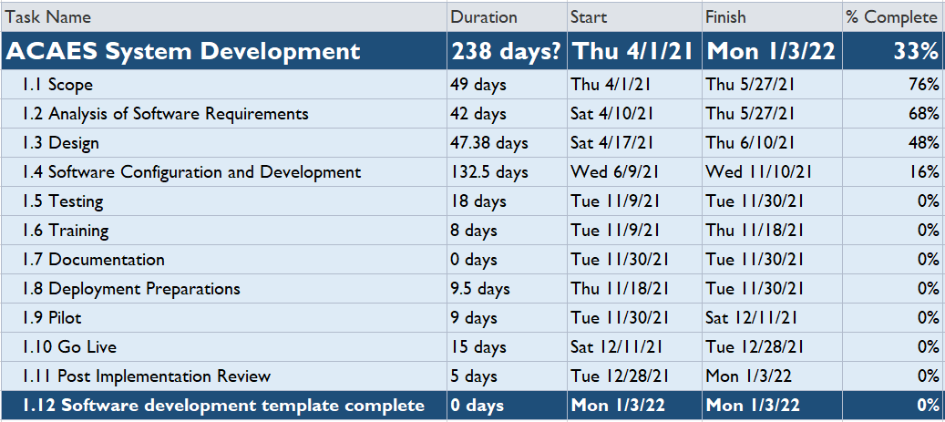

**Figure 7: Summary ACAES Project Schedule**

# Project Success Criteria

## Project Milestones

Based on the project work-plan there are ten milestones within the project which instantly have sub parts. The 10 milestones are listed below:

1. Completion of project scope
2. Completion of software requirement analysis
3. Completion of software design
   * Architecture design
   * Software design
   * Database design
   * Completion of backend/data structure
4. Completion of software configuration, development and prototype
   * Completion of Interface/ GUI development
5. Completion of software test
6. Completion of training plan and training
7. Completion of documentation
8. System Pilot
9. System go-live
10. Post Implementation

## Approval Process

The approval process is dependent on the ACAA senior management and end-users. Before the system goes into the approval process, the ACAES development team will check the system against ACAA requirements. In case any requirements are not reflected in the design or development, the requirement will be rescheduled. Every step and progress will be shared with the ACAA, Tt and USAID for their comments. The approval process shall include: 1. System check against requirements, 2. System performance check, 3. System quality control against best technical practices and against non-functional requirements. Performance and data security will play a prominent role in the evaluation process.

Once the system passes the approval process, the ACAA, Tt and USAID will make the final decision when to release the system into the production environment.

# Data Conversion / Data Migration

Data migration from any old ACAA database (if it exists) to the new ACAES database. A thorough study of ACAA shows that there is no proper database and the existing databases are excel sheets that have structure problems. Design rules for database structure are violated (data redundancy, no-relationship, non-unique primary key). To start with data migration to new data structure the following steps will be applied:

1. Moving records to a temporary database and breakdown into data and files
2. Analysis of the temporary data and mapping into new data structure
3. Upgrade of data quality by removing duplicates and building list tables
4. Build relationships with main data and list tables
5. Migration of the complete data to the new data structure
6. Analysis of the temporary structure regarding files, removing duplicates and storing in the file system with reference in the database



**Figure 8: Data migration flow**

# Test Strategy

The involvement of the ACAA IT team in the development ensures an ongoing test against real life situations.

## Unit Testing

This test is done at the lowest level by the technical team. It tests the basic unit of software, which is the smallest testable piece of software, and is often called unit, module, or component interchangeably. The unit testing takes place whenever a task is completed.

## Functional Testing

Functional testing is a quality assurance test that verifies the system against its requirements and specification documents. Each module or sub-system of the system is verified against its requirement specification document by the IT team and approved by the end-user.

## System Testing

System testing of software or hardware is conducted on a complete, integrated system to evaluate the system's compliance with its specified functional and nonfunctional requirements. System testing falls within the scope of black box testing, and as such, should require no knowledge of the inner design of the code or logic. On completion of each module, it will be piloted to its specific directorate with the intention to find out if it meets all their needs.

## Performance / Scalability Testing

The enterprise web-based application should be able sustain heavy load. Web performance testing should include:

1. Web Load Testing
2. Web Stress Testing
3. Test application performance in different locations within ACAA in order to test the system’s performance within different networks and hardware

# Release and Deployment Plan

Plans for the release and deployment of the system are linked to the overall service transition plan; the approach is to ensure an acceptable set of guidelines is in place, before the release into production. Release and deployment plans are authorized as part of the change management process. An elaborate change management plan will be utilized in ACAA to meet the new system’s operational requirements.

Release and deployment plan aims to deliver a functional system to ACAA within the specified timeframe. The goal of the deployment is to bring the system into production and establish effective use of the system in order to deliver value to the end-users. The release of the system shall be accompanied by suitable training material and documentation for maintenance.

Key points for release and deployment plan are:

1. Scope and content of the release
2. Risk assessment for the release
3. End-users affected by the release
4. Team which will be responsible for the release
5. Delivery and deployment strategy
6. Resources for the release and deployment

## Release and Pilots

Each release includes a pilot phase; the pilot phases are useful for testing the system with a small part of the user base before rolling it out in its entirety. It is important to determine the suitable scope of a pilot (how much of the system is to be included in the pilot, size of department or user base). The pilot includes steps to collect feedback on the effectiveness of the deployment plan. This can include surveying views and satisfaction from:

1. End-Users
2. Network Management
3. Data and knowledge management– statistics on use and effectiveness

## Build and test of releases

Key aspects that need to be managed during the activities to build and test a system/function are:

1. Check against the requirements
2. Infrastructure security, performance and connectivity test
3. Recording the build process so that it can be rebuilt if required
4. Maintaining evidence of testing, e.g. test results and test report
5. Checking that security requirements are met
6. Verification activities, e.g. prerequisites are met before a build or test begins

## Review and close a deployment

When reviewing a deployment, the following activities should be included:

1. Capture experiences and feedback on end-user satisfaction with the deployment
2. Review quality criteria that were not met
3. Check that any actions, necessary fixes and changes are complete
4. Make sure there are no capability, resource, capacity or performance issues at the end of the deployment
5. Check that any problems, known errors and workarounds are documented and accepted by the end-users
6. Incidents and problems caused by deployment, if any, should be documented.
7. Deployment is completed with a handover of the support for the deployment group.

## System version

System versioning is directly reflecting the system release, ACAES development team, ACAA IT team and end-user will clearly understand which version is running and what the next version will contain including the missing functions. The ACAES will be released in different phases, each of which is uniquely identified according to a defined scheme. The release identification should include a reference to the standard versioning that it represents and a version number that will often have two or three parts.

Example release names are as follows:

1. Major releases: system v.1, v2, v3 etc.
2. Minor releases: system v.1.1, v.1.2, v.1.9 etc.
3. Emergency fix releases: system v.1.1.1, v.1.1.2, v.1.1.14 etc.

# System Transition / Rollout Plan

Transition has to be responsive to the needs of the system and the people being affected by the system. Transition planning is the change management aspect of the planning process.

The ACAES transition and rollout has effects on the running processes, if the transition is applied completely in a single phase it is possible that ACAES will be faced with big challenges. From the project management perspective, it is not feasible to do the transition in a single phase, for good results the transition and rollout is planned to be carried out in different phases.

The following checklist should be applying for transition and rollout:

## Before Transition and rollout

1. Network connectivity with each end-users
2. The best security practices should be applied on the LAN
3. End-users should be trained
4. Local maintenance team should be in place for any quick problems
5. End-users credentials should be created with appropriate access roles assigned

## After Transition

1. End-users should be informed of any changes
2. Maintenance and support team should respond 24/7
3. Data should backup every 2-4 hours and full backups should be scheduled at the end of day
4. Power supply shall be redundantly available to resume on electricity disconnection
5. Backups shall be available for end-users and for maintenance team members

The overall transition and rollout plan is divided into the following three phases:

**Phase I**

Current data if any will be migrated to the new system and the database server for the **Contract and Revenue Management** system will be active. After the **New System server** is up and running, tax calculation, invoice generations, flight scheduling and contract registration will be performed with the new RMS and CMS system.

**Phase II**

Once phase I is successfully completed and the new systems are in use for two weeks, and once the testing is successful the overall manual process would be stopped and the system would be in place.

**Phase III**

After successful completion phase II, and successful running for minimum two weeks, then step by step each directorate will be redirected to use CMS and RMS

**Note:**

All the three phases will be repeated for the remaining modules of ACAES. In the next phase FIDS, FAS will be implemented then in order Asset, Crew and SMS systems will go-live..

# Training Plans

Training is a part of transitioning skills from the ACAES team to the ACAA IT team and end-users. According to the project plan the training will be provided for ACAA teams into three categories. First, high-end technical training for 8 days which is conducted in ACAA. This training will build the capacity of ACAA IT department (**please refer to training syllabus document for details**). Second, transition of technical knowledge about the system from the ACAES development team to the ACAA IT team. Third, end-user training which is conducted by the ACAES training team regarding the use of the system.

Positive features of the system which may help the end-users to quickly understand and get familiar with the functionality of the system are:

1. Standardized format and layout of screens. The end-user easily grasps the screen’s standard layout, which repeats itself in all screens
2. The system is in local languages, which also helps the end-user to quickly learn system functionalities
3. Screens are designed based on the manual form layout
4. Pilot training, during system piloting a small group of end-users are trained about how to use the system; this helps identify problems and issues with various training methods in a small group
5. Systems user manual; end-users complete workbook lessons in how to perform common tasks and functionalities. The system user manuals are drafted in the local languages with screenshots.

# Maintenance & Support Plans

Before system go-live technical guidelines for systems troubleshooting shall be in place. A qualified and well-structured technical team is required to do the maintenance operation. System maintenance shall have high priority for ACAA, once the application is up and running. Technical guidelines shall be strictly adhered to after the system go-live, e.g. servers-pc connectivity, data backup, physical and logical security of data, etc.

To keep the system updated and smoothly running with new technologies and requirements, regular development and improvement will be required to maintain the system by ACAA IT team. Also, the technical team will organize gatherings with end- users regularly to incorporate their feedback for system improvements.

**Support and Maintenance Team (ACAA IT team)**

The support and maintenance teams will be committed to provide exceptional service and support to each and every end-user within the different departments and functional units. The technical support team works closely with the development team to ensure that all functions within the system receives the best possible support and maintenance.